
FRIENDS OF THE EEL RIVER
Working for the recovery of our Wild & Scenic River, its fisheries and communities.

Monday March 21, 2021

Mendocino board of supervisors
501 Low Gap Road Ukiah CA 95482 Submitted by ecomment

Re: Proposed Phase 3 Commercial Cannabis Land Use Ordinance

Dear Supervisors,

Friends of the Eel River respectfully joins the environmental community of Mendocino County in urging you to find a better course for the future of commercial cannabis and healthy watersheds. If there is any urgency here it is of the Board’s own making.

As Ms. Doughty has eloquently explained to you in her comments on behalf of the Willits Environmental Center, “in its apparent short sighted haste and to avoid investing in an appropriate environmental analysis at the front end,” the County is moving to a system that will create impossible burdens for small operators, county staff, regulators and law enforcement.
FOER shares the WEC’s grave concerns about the increase in environmental impacts the proposed ordinance will cause and supports their comments to your Board.

The Mendocino County Board of Supervisors has previously acknowledged the serious impact of unregulated cannabis production across the county, including the critical impacts that development can have on watercourses and the salmon which they support. Take, for example, Tomki Creek on the mainstem Eel River, which reliably supported hundreds and thousands of spawning salmon every year. The following chart, published by Pacific Gas and Electric in 2017, shows that chinook returns to Tomki Creek declined abruptly in 1989. They have never recovered.

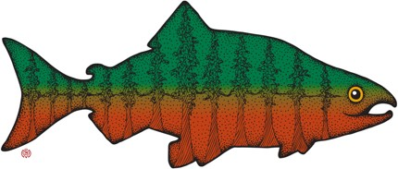
HUMBOLDT OFFICE
707.798.6345 • foer@eelriver.org
PO Box 4945, Arcata, CA 95518

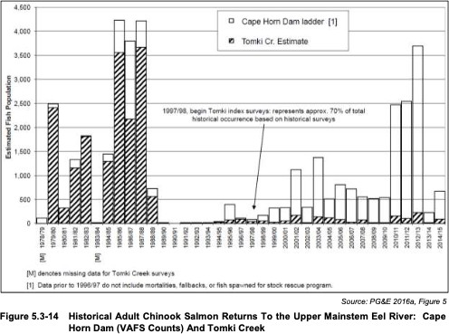

Mendocino County is responsible for protecting – and for failing to protect -- Tomki Creek as habitat for its native salmon. Bringing them back means fixing a lot of things (roads, stream crossings, grading and so forth) which the County has knowingly failed to address for decades. Encouraging a new wave of development into remote areas is the last thing responsible regulators would do.

As many commenters have pointed out, Mendocino County is completely failing to do even basic enforcement on unpermitted cultivation today. The proposed ordinance offers nothing to suggest that this will change. Rather, the idea appears to be to shirk the county’s burden of enforcement and of meaningful environmental review as much as possible. In practice, this will place substantial additional burdens on the California Department of Fish and Wildlife’s already overstretched permitting and enforcement capacities.

As the following chart shows, CDFW already lacks the resources to carry even 30% of the agency’s current permitting workload, while two-thirds of its law enforcement responsibilities go unmet. Meanwhile, the agency’s critical work to protect species and conserve habitat has barely a quarter of what it needs to do its job. This is the agency Mendocino County wants to pretend will be there to clean up when the county fails to plan and direct land use to prevent lasting environmental harms.

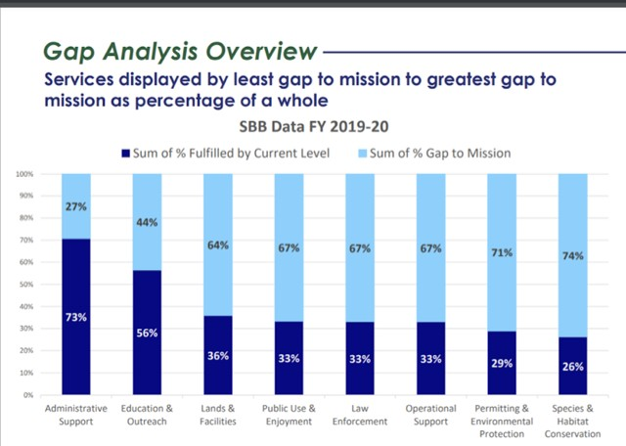

More to the point, DFW is not a land use agency. It is the county’s responsibility to plan for, direct, and regulate land use so that it will not unnecessarily create a significant impact on our natural heritage. As WEC points out, it is the county, its citizens, and its environment that will be left holding the bag when the piper comes.

Perhaps the most pervasive misunderstanding of the nature of the watershed impacts of widespread commercial cannabis cultivation on salmon and steelhead is the relative significance of sedimentation versus water withdrawals and pollution. Our best rough estimate remains that sediment impacts account for about 90% of the harms to salmonids in the Eel River watershed from pot production, while water withdrawals are maybe 9% and pollution the remaining 1%.
Thus, reducing and preventing cumulative sediment impacts from roads, stream crossings, and grading are a critical element of preventing harms to critically imperiled Eel River salmon and steelhead.

To provide for a sustainable cannabis industry in Mendocino County, the board should limit future development to operations serviced by county-maintained roads. As well, we implore the county to absolutely ban the use of hauled water for any use associated with a commercial cannabis operation. FOER strongly agrees with WEC and others who oppose the 10% ceiling as inviting otherwise unsustainable and undesirable development.

Any use of surface water should comply with forbearance rules under state regulations. FOER strongly encourages Mendocino County to impose the same seasonal storage and forbearance requirements on well users.

The flimsy structure the county proposes is one the wealthy and politically powerful will find convenient to their needs. But it will be a trainwreck for everyone else, including the county’s citizens and, we fear, its ecosystems. It is hard to square the proposed ordinance with the board’s duty to provide for the health and general welfare of county or of its natural resources.

Sincerely,
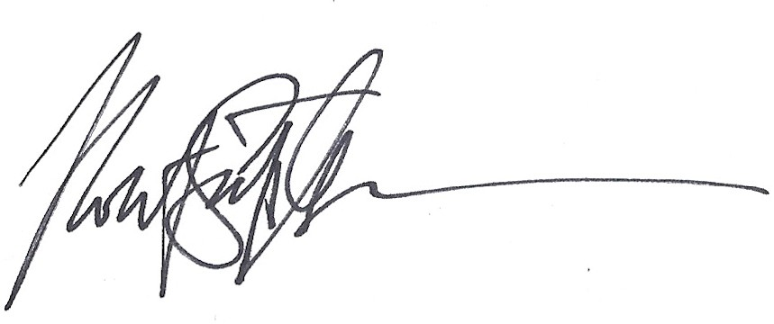
Scott Greacen Conservation Director

