Monitoring and Population Suppression of Invasive Sacramento Pikeminnow in the South Fork Eel River
A couple of the larger Pikeminnow captured during boat electrofishing.
Recent fisheries restoration and conservation efforts in the Eel River basin have largely focused on improving and protecting stream habitats, while less emphasis has been placed on understanding and mitigating adverse impacts of non-native aquatic species. Non-native predatory fish can limit the productivity of already diminished native fish populations, limiting their ability to persist in degraded habitats and to recover in response to habitat restoration efforts. Of particular concern in the Eel River basin is the non-native Sacramento Pikeminnow, Ptychocheilus grandis, a large piscivorous cyprinid that was introduced into Lake Pillsbury in the upper mainstem Eel River around 1979 and has since expanded its distribution into much of the basin.

In 2018, the Wiyot Tribe and Stillwater Sciences initiated Phase 1 of a collaborative project to address multiple questions regarding invasive Sacramento Pikeminnow biology and management in the South Fork Eel River, focusing on the reach between Rattlesnake Creek and the confluence with the mainstem Eel River. Primary goals were threefold: (1) describe pikeminnow abundance and distribution in the study area, (2) develop and test population suppression methods, and (3) improve understanding of impacts on native fish. We performed snorkel surveys during summer on a spatially-balanced subset of 1-3 km (0.6-1.9 mi) reaches to count pikeminnow in different size classes. A total of 21.6 km (13.4 mi) of stream was surveyed and over 6,400 pikeminnow larger than 4 inches were observed (Table 1). Based on numbers observed in sampled reaches, 31,121 individuals larger than 4 inches were estimated to be present in the entire study area 105 km (65 mi). Snorkel survey results were used to identify pikeminnow “hot-spots” and will be compared with future surveys to monitor population trends.
Table 1. The number of Pikeminnow observed at the snorkel sites and the estimated number within the study area.
Size Class | <4 in | 4-8 in | 8-12 in | 12-18 in | 18+ in | All sizes
Counted | 10,678 | 4,564 | 1,195 | 525 | 155 | 17,117
Estimated | 51,610 | 22,059 | 5,776 | 2,537 | 749 | 82,731

Pilot-level efforts to test different pikeminnow population suppression methods were initiated in the South Fork Eel River study area in summer 2019, and focused on boat electrofishing, baited box traps, seining, and angling (Figure 1). Boat electrofishing was the most effective method tested for capturing pikeminnow larger than eight inches, but was limited to the lower portion of the study area to minimize impacts on juvenile salmonids, which are more common in upstream reaches where water temperatures are cooler. Large box traps—baited with roe, anchovies, or chicken liver—were also tested. Chicken liver was clearly the most effective bait attracting for juvenile pikeminnow. The baited box traps were fixed with a GoPro camera to help monitor their effectiveness (Figure 2). Seining proved effective for capturing large numbers of the smaller, younger pikeminnow (<4 inches), but initial trials suggest limited effectiveness for larger sized fish. Additional evaluation of suppression methods is planned for 2021 and 2022.
Figure 1. Boat electrofishing on the lower South Fork Eel River.
To assess predation on native fish, in particular juvenile salmonids and lamprey, pikeminnow captured during summer electrofishing and winter angling were euthanized and their gut contents were examined. The summer samples showed smaller (4-12 in) pikeminnow fed primarily on insects, medium (12-18 in) pikeminnow on a mix of insects and unidentified small fish, and large (18+ in) pikeminnow almost exclusively on crayfish. Interestingly, the winter gut contents were largely empty. Notably, we did not collect diet samples during the spring smolt outmigration period, when a greater degree of overlap with juvenile salmon, steelhead, and lamprey is expected.
Figure 2. Juvenile Sacramento Pikeminnow approximately 4-8 inches in length inside a box trap baited with chicken liver.
In 2020, the Wiyot Tribe and Stillwater Sciences, with support from a Technical Advisory Committee, initiated Phase 2 of the project, which will extend through 2023. Key objectives of Phase 2 include (1) continued population monitoring to evaluate trends in abundance, (2) further testing and refinement of pikeminnow suppression methods and application within the study area, (3) tagging of pikeminnow to track movement throughout watershed and improve abundance estimates, (4) description of age structure and growth patterns of pikeminnow using scale analysis and (5) expanded diet evaluations, including during the spring outmigration period. Stable isotope diet analysis will be applied to provide information on pikeminnow prey composition over a longer time period (weeks to months) compared with gut contents (hours). After completing the tasks listed above, we will work with key stakeholders to develop an Eel River Pikeminnow Management Plan that integrates information from past studies with new data collected by this project and others. The Plan will (1) evaluate population-level impacts of pikeminnow predation on native fish in the Eel River, (2) describe the level-of-control and cost required to remove sufficient pikeminnow to result in a meaningful increases in survival and production of native fishes; and (3) make specific recommendations for implementing future pikeminnow monitoring and population control in the Eel River Basin, including best approaches, locations, timing, life-stages, and considerations for adaptive management.
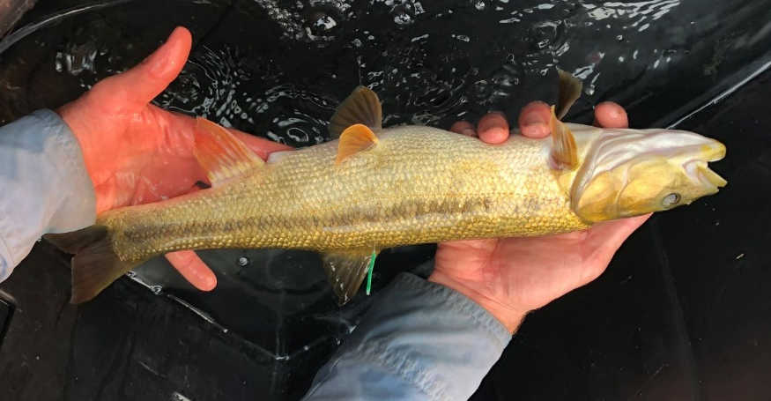
We will be out on the South Fork Eel in the coming months so feel free to stop by and check out what we are doing. We have started to tag pikeminnow with colored Floy tags to help track movement, so keep an eye out and please report if found (Figure 3). Additionally, we are looking for any information on pikeminnow occurrence, movement, or capture techniques (spearfishing is not currently permitted) you may have, especially during the winter and spring months. Please contact Sam Rizza at srizza@stillwatersci.com for more information or to share your pikeminnow knowledge.
Figure 3. Floy tagged Sacramento Pikeminnow. Let us know if you see one!

